Entradas |  |  | Salidas
A | B | C | Led1 | Led2
0 | 0 | 0 | 0 | 0
0 | 0 | 1 | 0 | 0
0 | 1 | 0 | 0 | 0
0 | 1 | 1 | 0 | 1
1 | 0 | 0 | 0 | 0
1 | 0 | 1 | 0 | 0
1 | 1 | 0 | 1 | 0
1 | 1 | 1 | 1 | 1

Formulas:
Led1:
A*B*(C-)+A*B*C

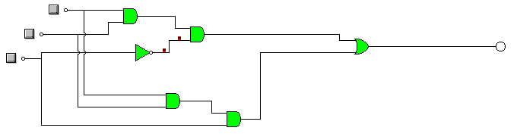
Led2:
(A-)*B*C+A*B*C

